**LCS Cable Guide**

**Communication Cable**

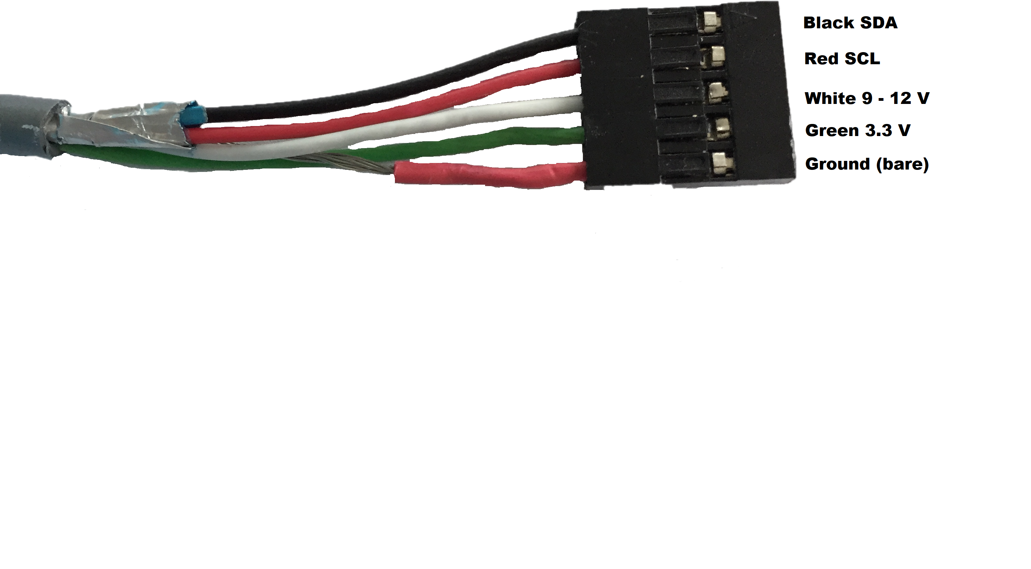

**This cable is used to connect the controller board to module boards. The cable can also be connected between two module boards.**

**Turnout Motor Cable**

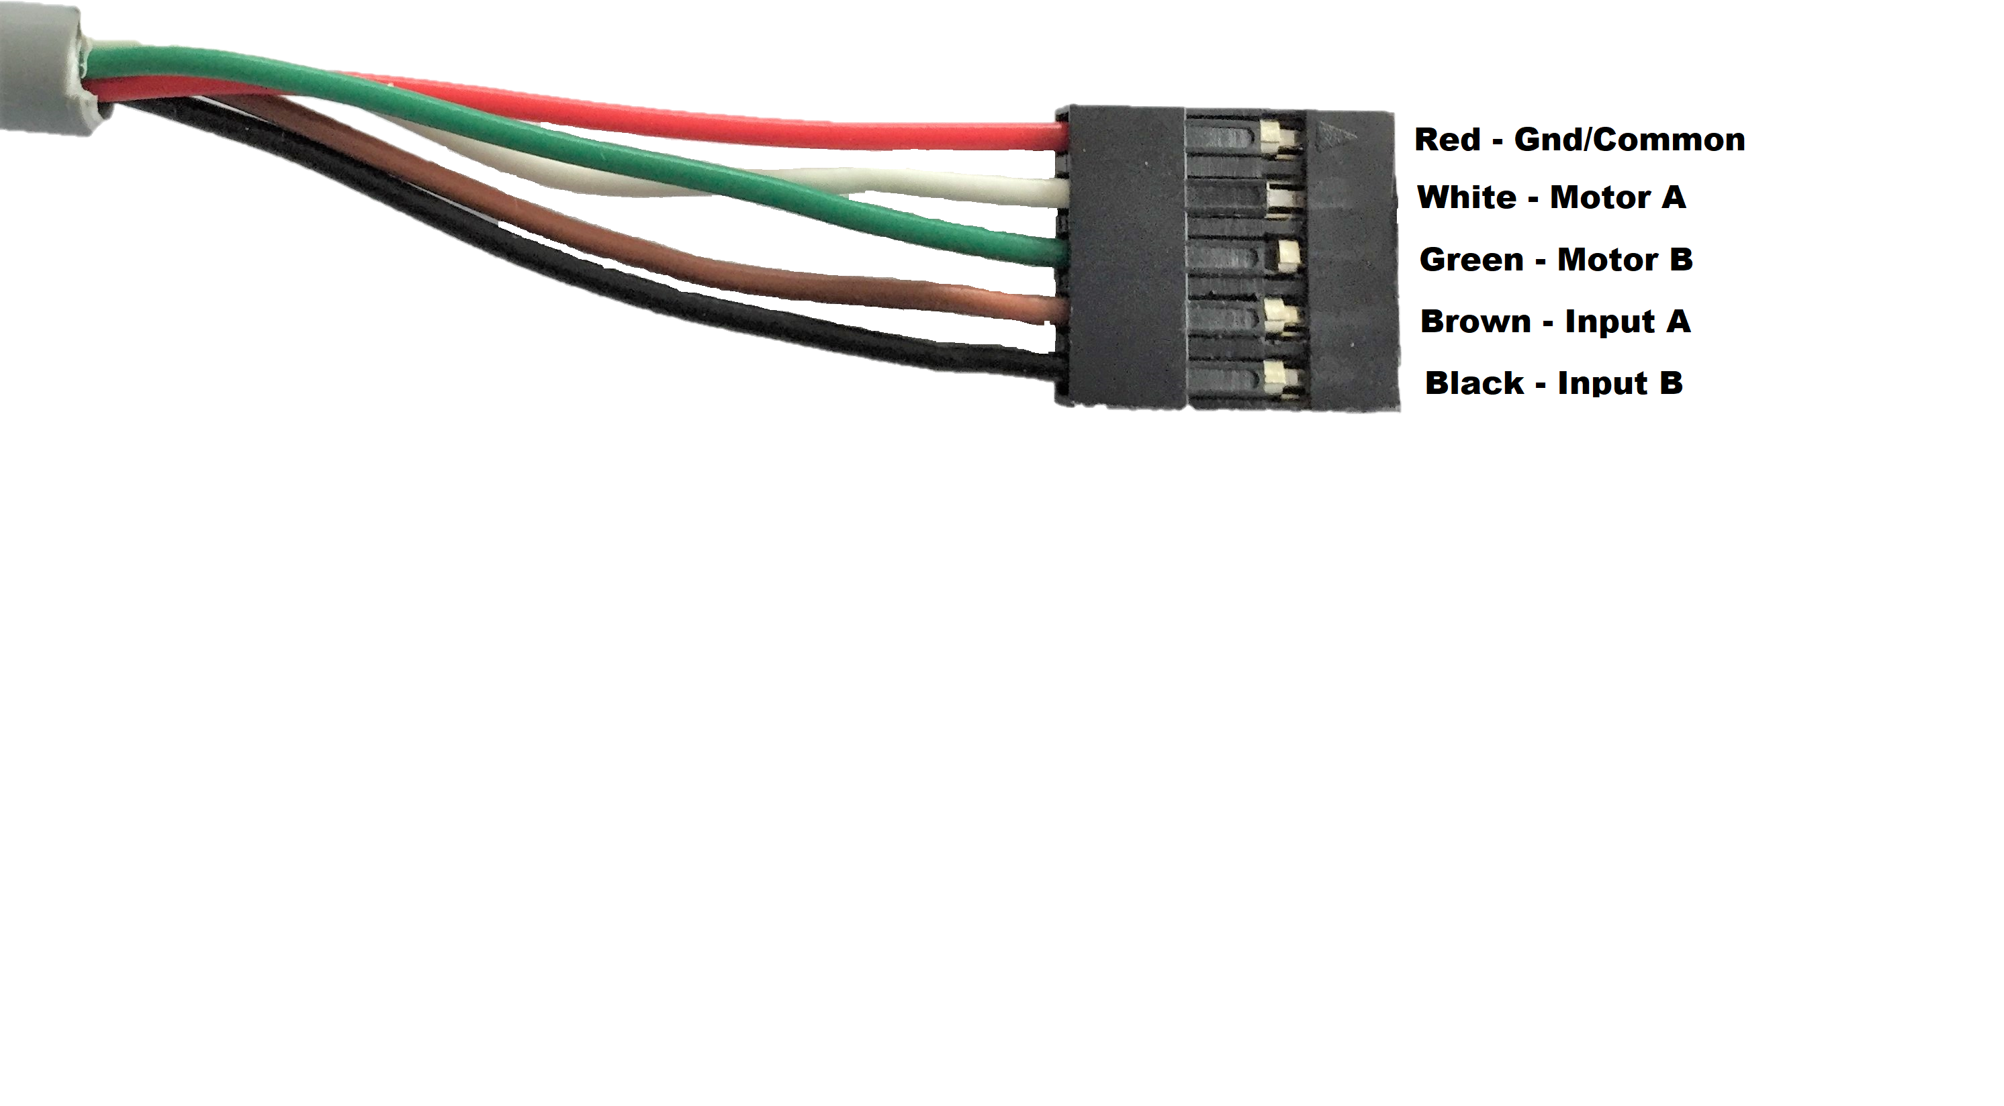

**This cable connects a Turnout Module board to a turnout motor.**

**Note:**

**White:** Motor +

**Green:** Motor –

**Brown:** Signal-Main

**Black:** Signal Diverging